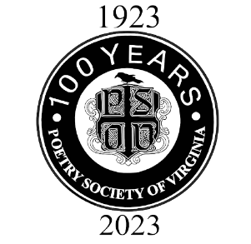
WANTED: PSV Volunteers

The following roles are a priority for PSV and need to be filled immediately. All of these are volunteer roles.
- Fundraising Chair and Committee (To help shape and drive fundraising campaigns)
- Grant Strategists and Writers (To develop a grant-seeking strategy and apply for program and operational funding)
- Director of Youth Initiatives (To oversee the planning, execution and growth of all youth programs and projects managed by PSV. Additionally, to nurture a safe, friendly, and supportive poetry ecosystem for youth, their families, teachers, PSV members and our communities.)
- Strategic Partnerships Manager (To build community relationships and partnerships in order to expand PSV’s reach, have access to additional resources, and increase the value of membership.
- Social Media Committee (To help manage PSV’s social media posts and campaigns and promote PSV activities)
- Website Assistant (To update content and information on our website, as needed)
- External Newsletter Editor (To manage the newsletter that will be distributed to non-PSV readers)
- Ongoing Volunteers (For virtual and live events, especially our Annual Festival, and to assist when committees need to complete big tasks)
- Photographers (Anyone skilled in the art of capturing photos at events. Photographers will partner with the Member Newsletter, Social Media and Publicity Committees.)

Please send a note of interest to Cherryl Cooley at:
poetrysocietypresident@gmail.com
Be sure to highlight any relevant experience you have to perform the role. Also, please send along any questions about these roles or refer someone who might be interested and a good fit. Membership in PSV is expected for Fundraising, Social Media, Website, and Newsletter roles.

